

COMP 5350 Project 2 Report

Laura Wilson and Jess Banister

Group 5

20 October 2023

# Executive Summary

In this project, we were tasked with creating a program in Python that can import a disk image and find the different files that are stored in the image. There are eight different file types that we are looking for and are being extracted in the program. We were tasked with looking for MPG, PDF, BMP, GIF, JPG, DOCX, AVI, and PNG. The program also has the ability to reroute the files that are extracted to a folder that way all of the recovered files are in the same place. Upon running the program we were able to find 13 files in total. We found one MPG file, two PDF files, two BMP files, two GIF files, three JPG files, one DOCX file, and two AVI files. Screenshots of the files collected are going to be under the “List of Figures” section with a brief description of the file contents. In the program, we were also tasked with finding the starting and ending offsets of the files and displaying them to ensure that we were extracting the file correctly. A table with all of the offsets of the files will be under the “List of Tables” section. We did notice that in the .docx file, there was a code and a note that said, “BESURETODRINKYOUROVALTINE” which is a reference to an advertisement campaign in the movie A Christmas Story. When loading the code into your VM you need to change the “path” to the directory that you are running the program in. The path for “RecoveredFiles” also needs to be changed to the location where you wish for the files to be extracted to. Another note is that you need to ensure that there are no duplicate files similar to the ones that are going to be extracted.

# Collaboration Summary

To start the project we connected over Discord where we discussed that Jess would write the Python program that would collect and display all the files from inside Project2.dd disk. A Google Document was also made so that we could share our findings.

For the report, Jess took all the screenshots for the PDF, BMP, GIF, JPG, DOCX, and PNG files and filled in the tables related to all the files that were collected. Laura took the screenshots of the MPG, and AVI files that were collected, and grammar corrections were made.

# Problem Description

The main objective of this project was to create a Python script that would take the disk image provided to us as the input and output each of the file signatures, the SHA-256 hash, and recover the files correctly. The files that were in the disk image Project2.dd that we needed to retrieve were one MPG file, two PDF files, two BMP files, two GIF files, three JPG files, one DOCX file, and two AVI files making a total of 13 files that we need to extract correctly.

Each signature of the files needed the header and the footer so that we could figure out where the start and end of the file were. For the start and end offset, we needed to convert the offset into a different format using a formula. The SHA-256 hash was the same for each file as we used ‘sha256sum ‘ + str(gifFile) to equal the hash and then display it. In the “List of Tables” section each of the file's start offset, and end offset are displayed.

In our video, we talk more in-depth about how each file’s start offset, end offset, and SHA-256 hash are calculated and displayed as well as what the output of our program looks like.

# Description of analysis techniques utilized

To start the project we first collected the different signatures of the different types of files that we would be looking for by using the slides provided to us in “Lecture #7”. With those we put the header and footer signatures of each file into our program so that our program would know where the start and end of the different files were. Then after we identified the file using the header and footer of that file type we calculated the start and end offset using different equations for the start offset and end offset. The SHA-256 hash was collected using an equation, which can be seen in the “Project Description” section. How the files were collected was by the recovery command dd if=Project2.dd of= (File name) bs=1 skip= (start offset) count= (file size) and then stored in the Recovered Files folder that was created separately before starting the program. The list of all the files recovered is in the “List of Figures” section as well as explained more in-depth in our video.

# List of Figures

File1.mpg:

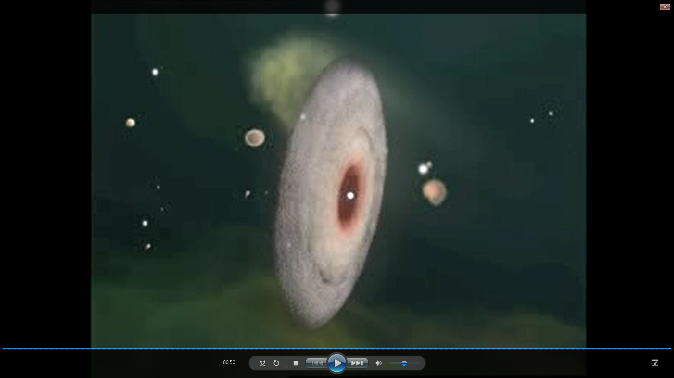

File2.pdf:

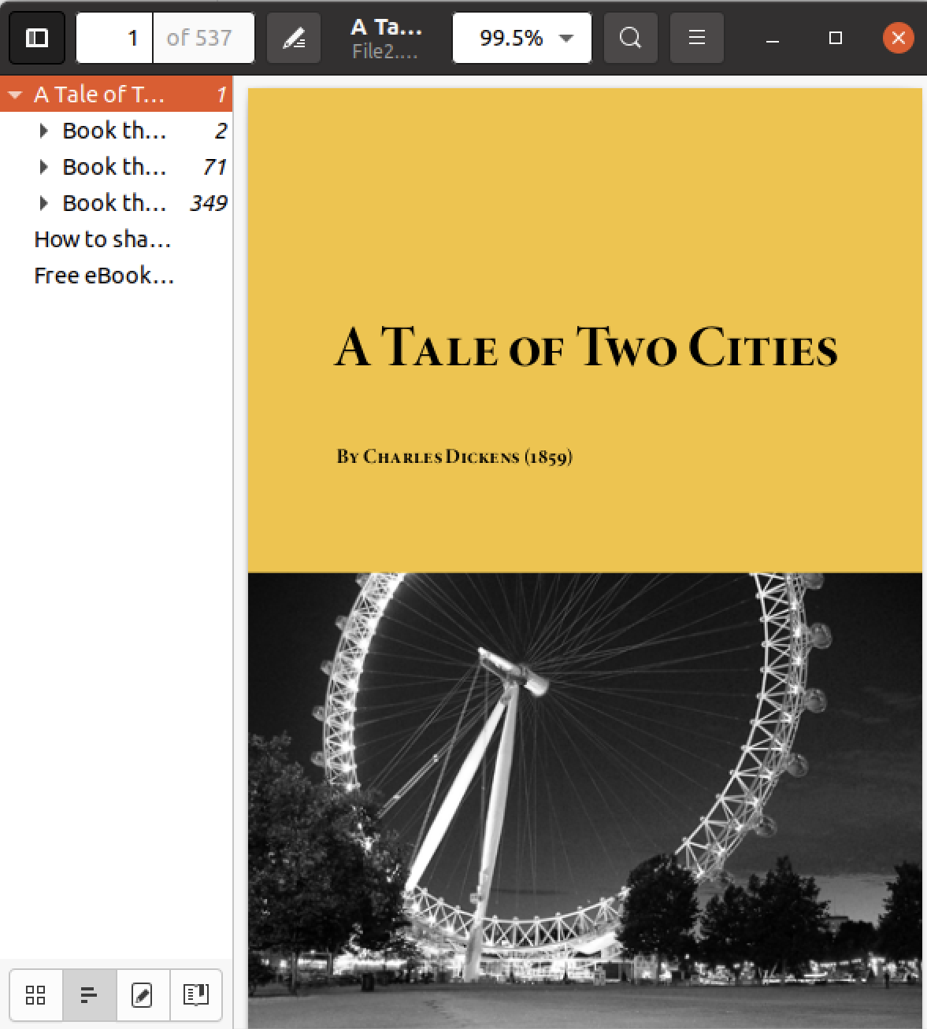

File3.pdf:

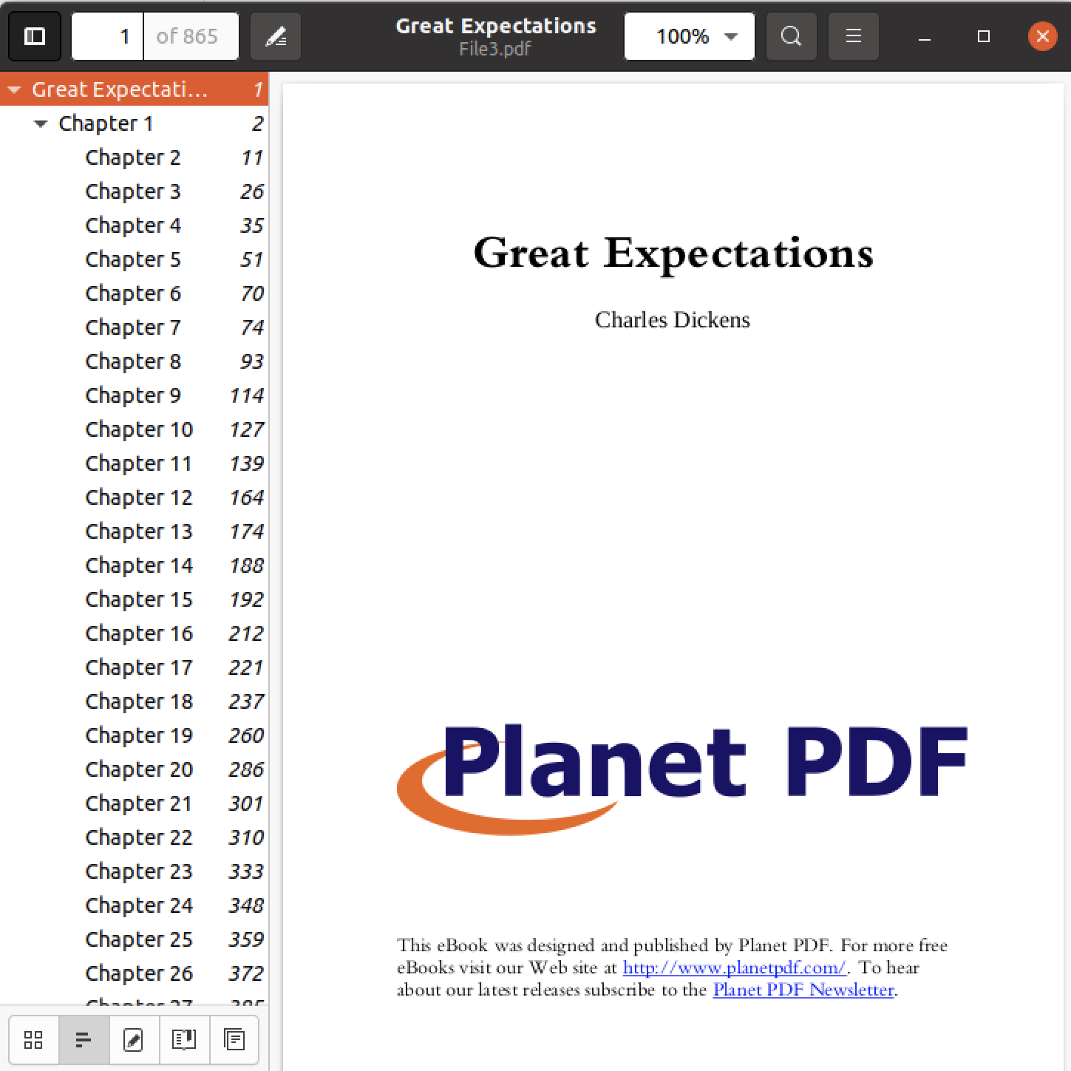

File4.bmp:

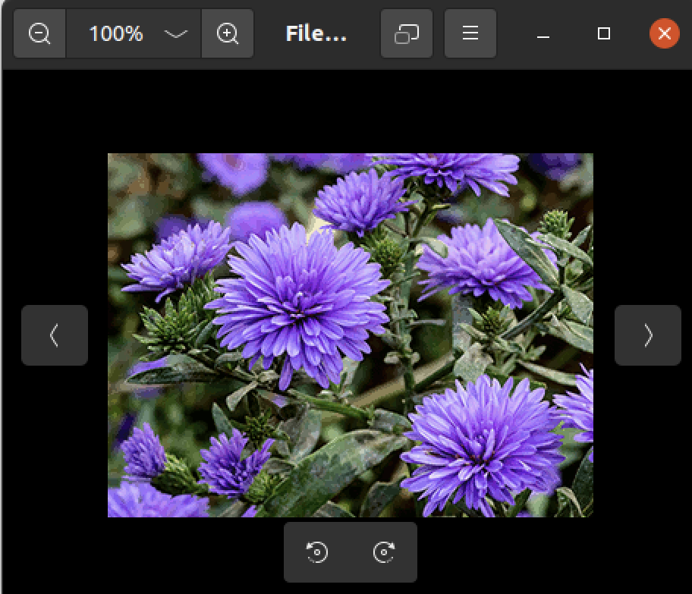

File5.gif

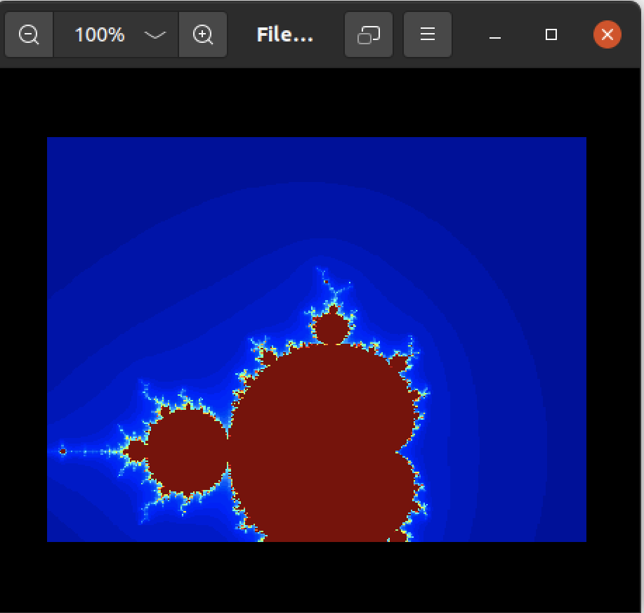

File6.gif:

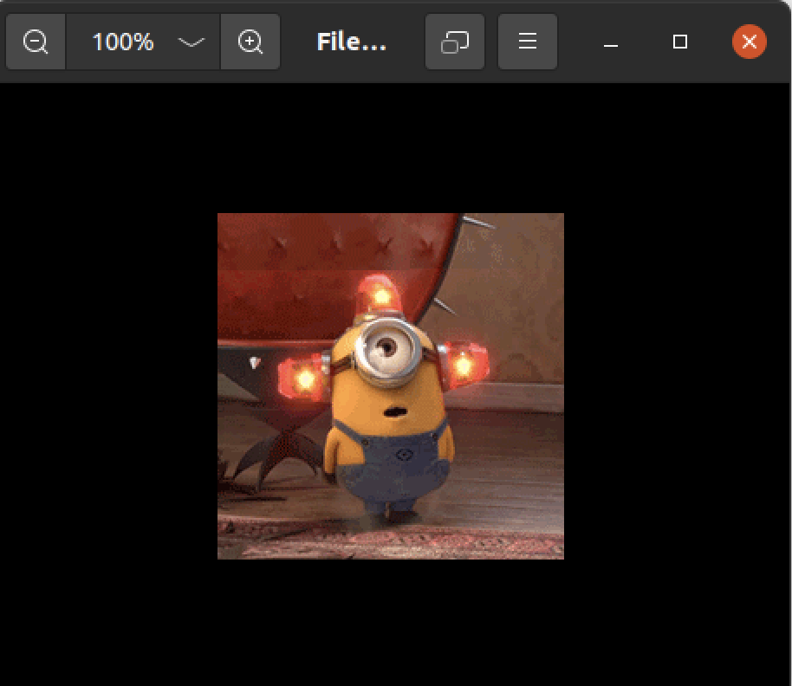

File7.jpg:

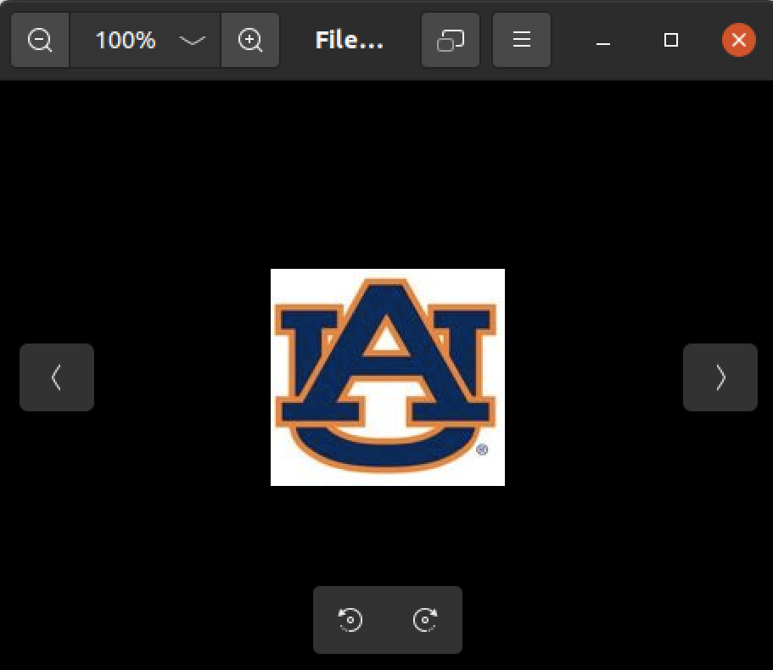

File8.jpg:

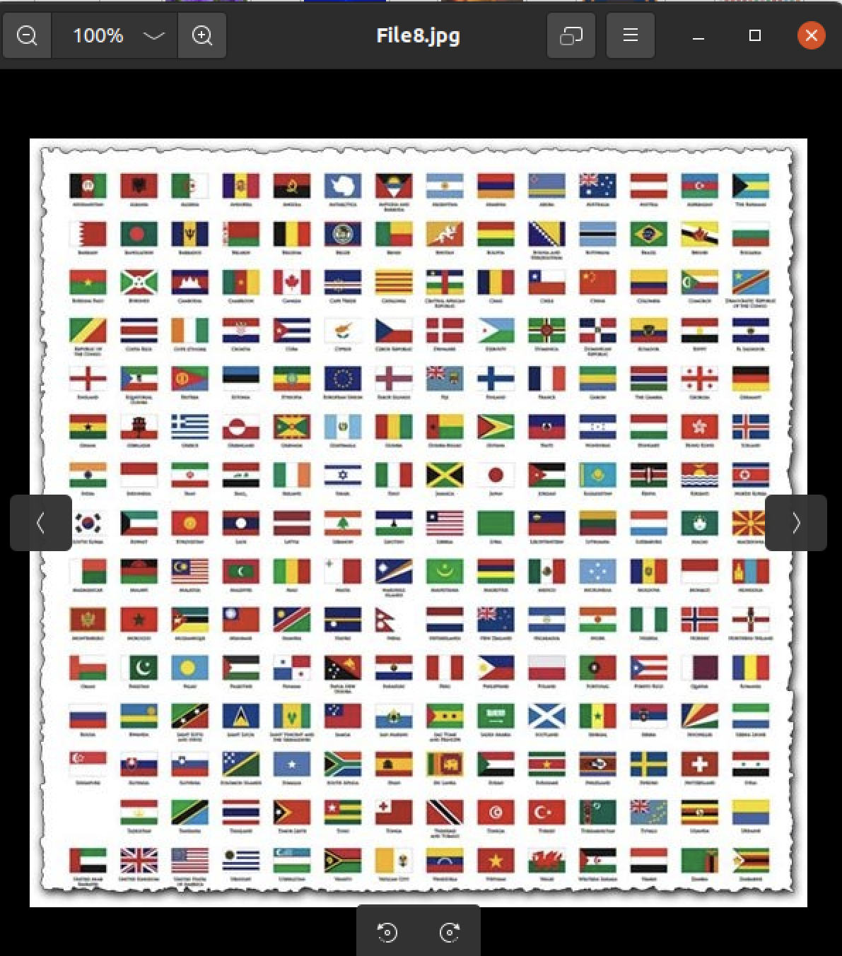

File9.jpg:

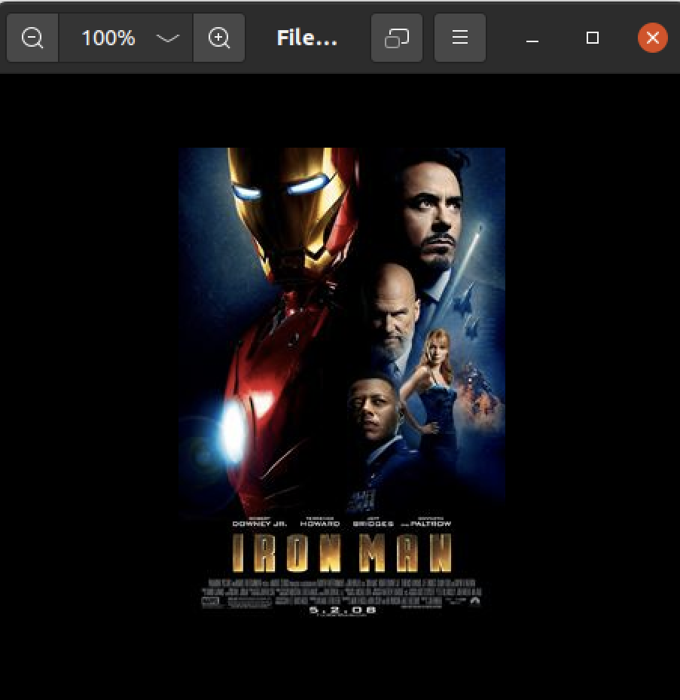

File10.docx:

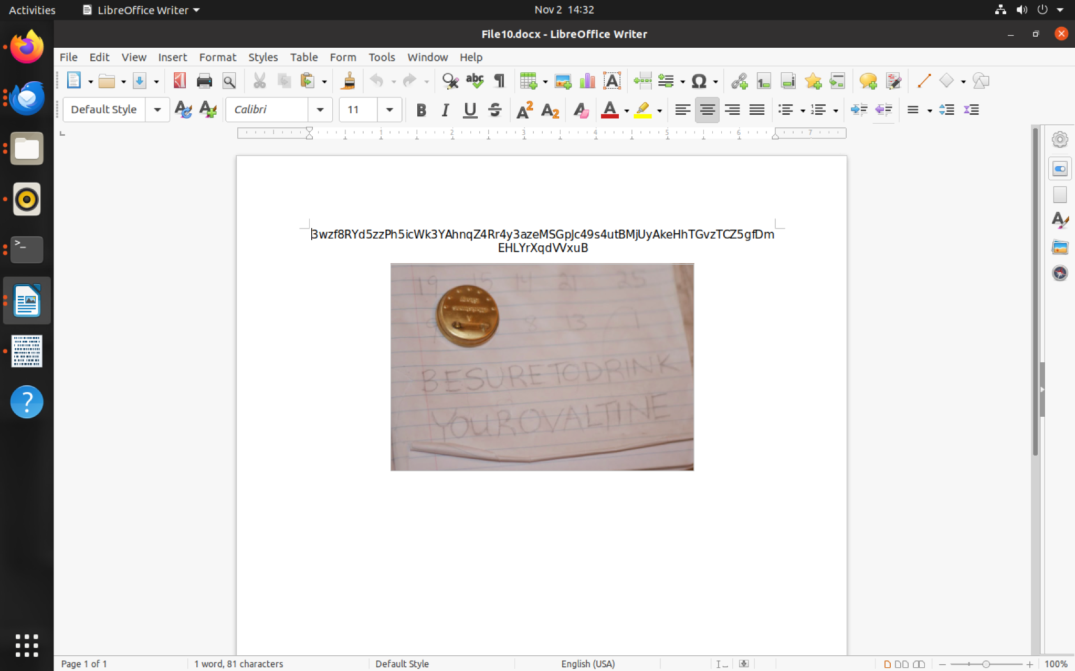

File11.avi:

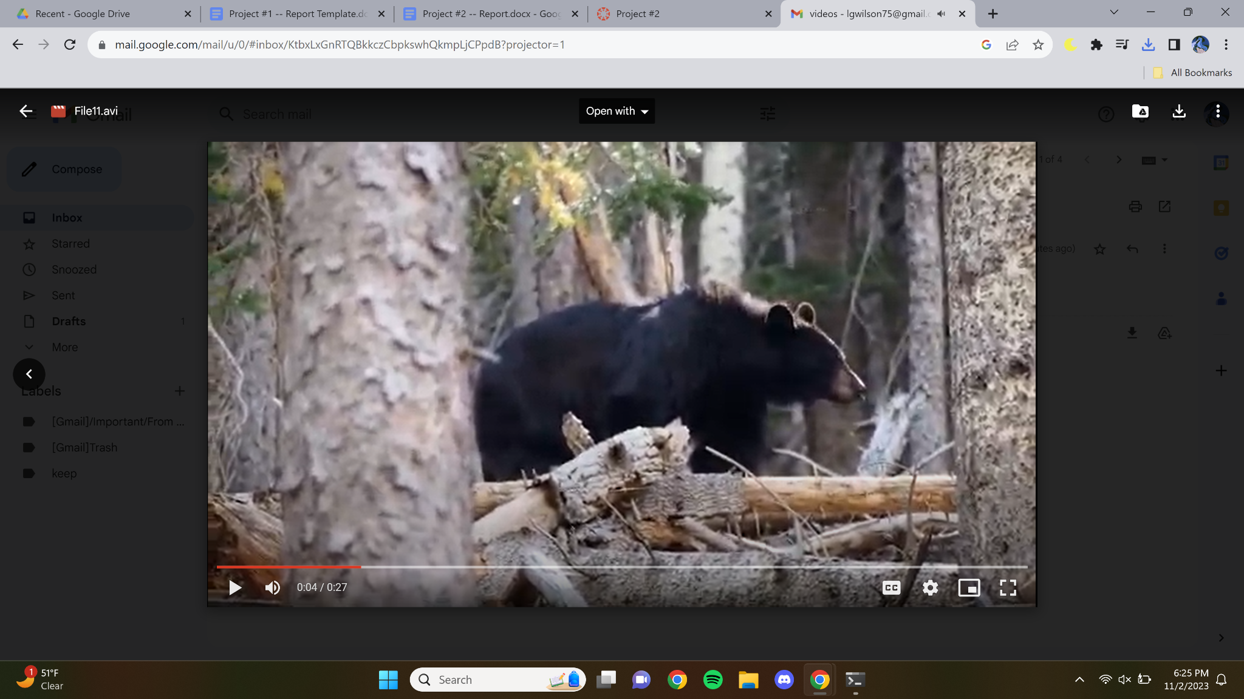

File12.avi:

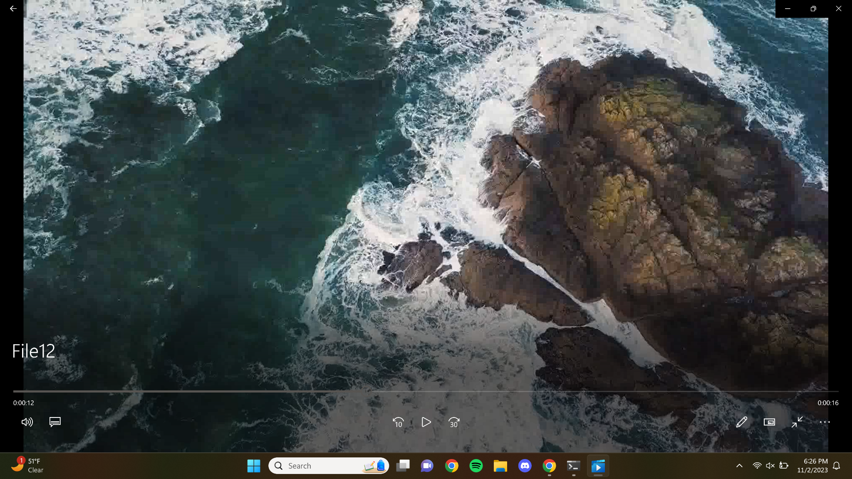

File13.png

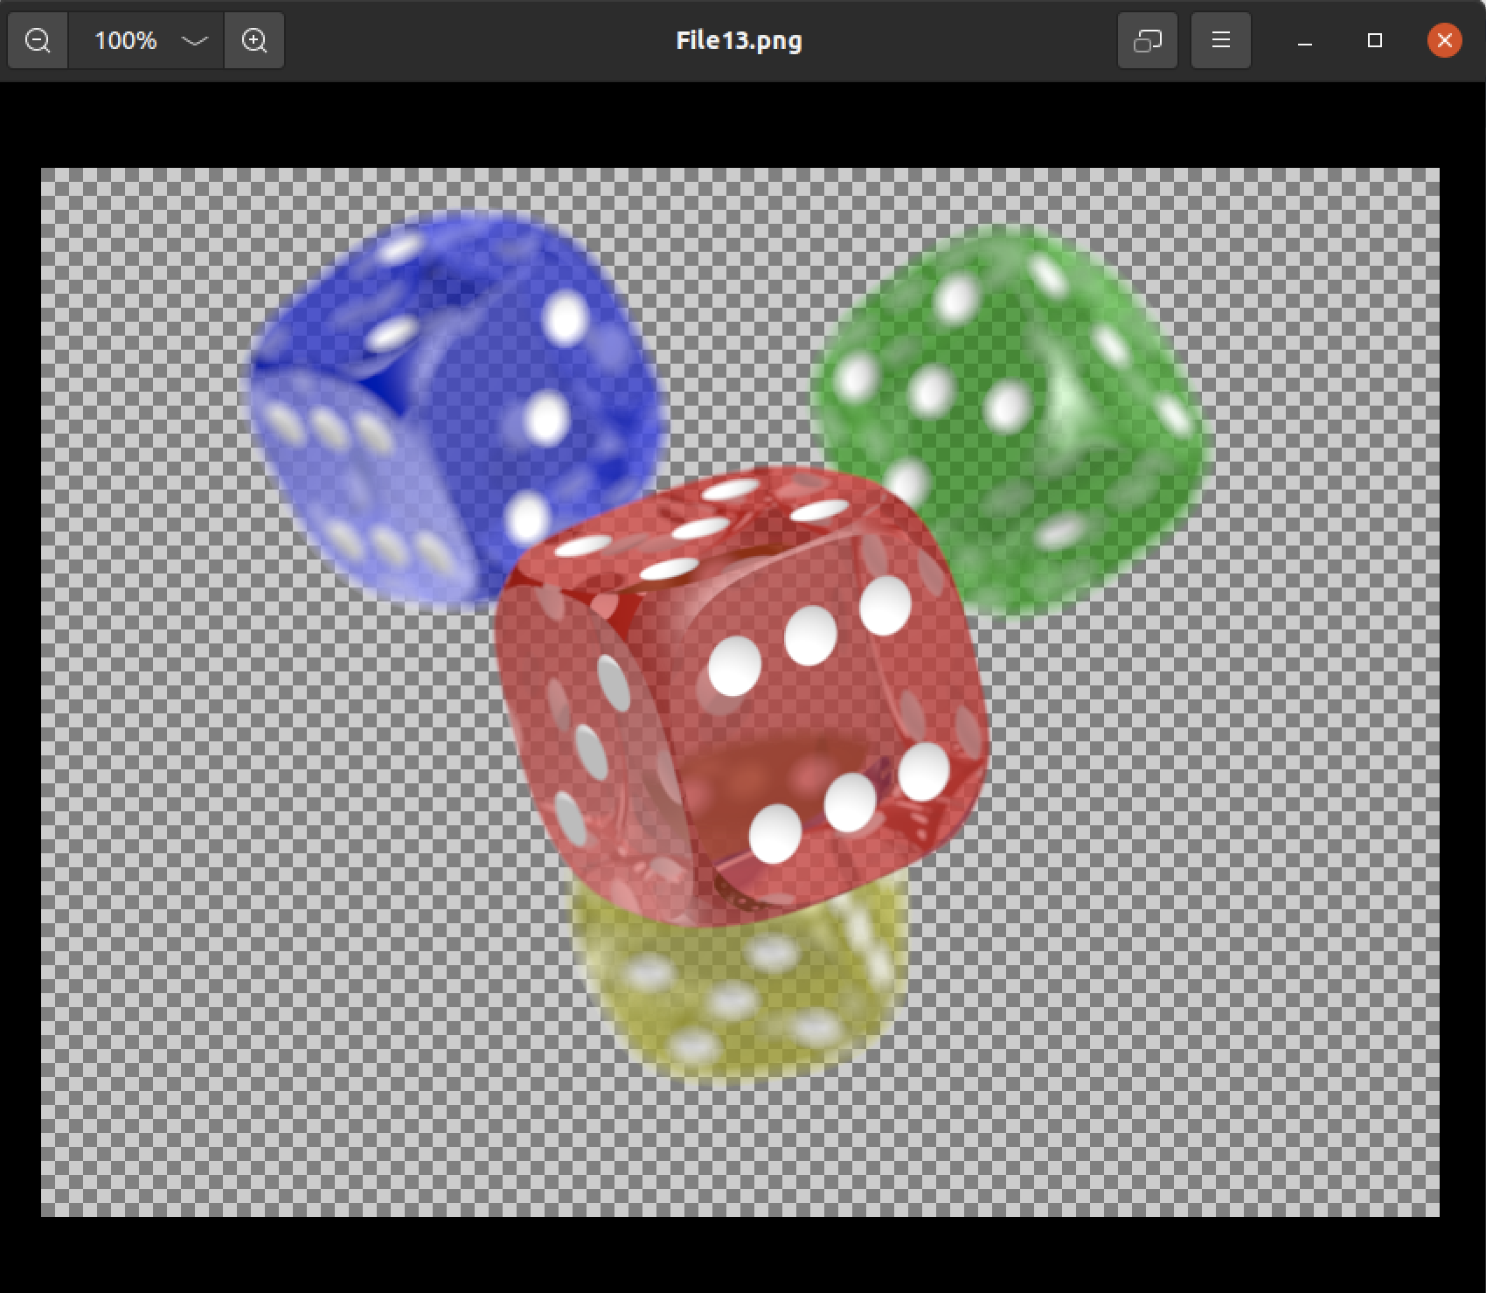

# List of Tables

| Real File Name | Output name | Starting Offset | Ending Offset |
| --- | --- | --- | --- |
| Universe.mpg | File1.mpg | 0x2dbd000 | 0x2faf8ac |
| Cities.pdf | File2.pdf | 0x1be1000 | 0x1dd8491 |
| Great.pdf | File3.pdf | 0x1e3c000 | 0x2147c7c |
| Flower.bmp | File4.bmp | 0x1e38000 | 0x1e3b076 |
| Mandelbrot.gif | File5. gif | 0x214e000 | 0x215dd83 |
| Minion.gif | File6.gif | 0x23d6000 | 0x23e8c2b |
| Auburn.jpg | File7.jpg | 0x38000 | 0x3b055 |
| Flags.jpg | File8.jpg | 0x1e11000 | 0x1e27992 |
| Iron.jpg | File9.jpg | 0x2148000 | 0x214d72f |
| Question.docx | File10.docx | 0x2d9b000 | 0x2dbc5b7 |
| Bear.avi | File11.avi | 0x3c000 | 0x1be0a88 |
| Ocean.avi | File12.avi | 0x2427000 | 0x2b9a36c |
| Dice.png | File13.png | 0x1dd9000 | 0x1e10a7b |

# Conclusions and recommendations

One correction that we will make for extracting different files is to remember that the AVI file types take a considerable amount of time to extract than any of the other files. To counteract this we will extract the AVI more efficiently by improving our program so that these files don’t take a long time to be extracted.

In conclusion, this disk image contained 13 different file types. These file types are one MPG file, two PDF files, two BMP files, two GIF files, three JPG files, one DOCX file, and two AVI files. Each of these files had different header and footer signatures to find so that the right start and end offset could be calculated. Also, each file had a different size and different name for them to be extracted from the Project2.dd disk image correctly without being corrupted.

# 

# 7 References

[1] GCK’s file signatures table. [updated 2023 Oct 29; accessed 2023 Nov 3]. [ttps://www.garykessler.net/library/file_sigs.html](https://www.garykessler.net/library/file_sigs.html)

[2] Stack Overflow. Python moving files and directories from one folder to another. 2014 Dec 18 [accessed 2023 Nov 3]. <https://stackoverflow.com/questions/27545454/python-moving-files-and-directories-from-one-folder-to-another>

[3] Datagy. How to Move Files in Python(os, shutil). 2022 Nov 18 [accessed 2023 Nov 3].

<https://datagy.io/python-move-file/>

[4] Python. os -Miscellaneous operating system interfaces. 2023 Nov 3 [accessed 2023 Nov 3].

<https://docs.python.org/3/library/os.html?highlight=os%20system#os.system>

[5] merrymitch. Github. FileRecovery.py. 2022 Nov 7 [accessed 2023 Nov 3]. <https://github.com/merrymitch/COMP5350/blob/main/Project2/FileRecovery.py>